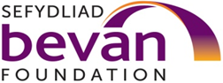

Three Towns Project: Participant Consent Form
The Bevan Foundation develops new ideas to make Wales a fairer, prosperous and sustainable place. We are independent of government or any political party, and are funded by subscriptions, donations, grants from charitable trusts and foundations and commissions
You have been asked to complete this consent form as you have agreed to take part in an interview or focus group as part of the Three Towns project.
Please read the information sheet and sign or initial the boxes below.
Please sign or initial here
I have read the Participant Information Sheet fully and have understood the purpose of the study and what will be required of me if I choose to participate.
I have had an opportunity to discuss the study with the researcher and have had any questions I had satisfactorily answered.
I understand that I am able to withdraw from the study at any point without giving a reason.
I understand that the information I share during the interviews may be used anonymously in a report to the Welsh Government.
I agree to share my story in a report.
I agree to take part in this project.

Name of Participant

Signature

Date

Name of Researcher

Signature

Date

Acknowledgements

This consent form was produced as part of “three towns” project, surfacing the potential of the foundational economy in three different valleys communities. We would like to thank the Welsh Government for supporting and funding this project.

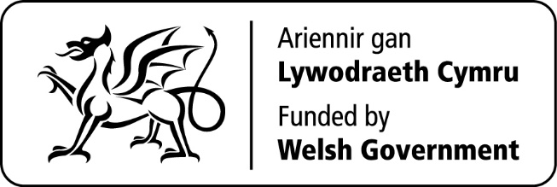

Copyright the Bevan Foundation
April 2020
Bevan Foundation
145a High Street,
Merthyr Tydfil
CF47 8DP
info@bevanfoundation.org www.bevanfoundation.org

Registered charity no. 1104191 Company registered in Wales no. 4175018

