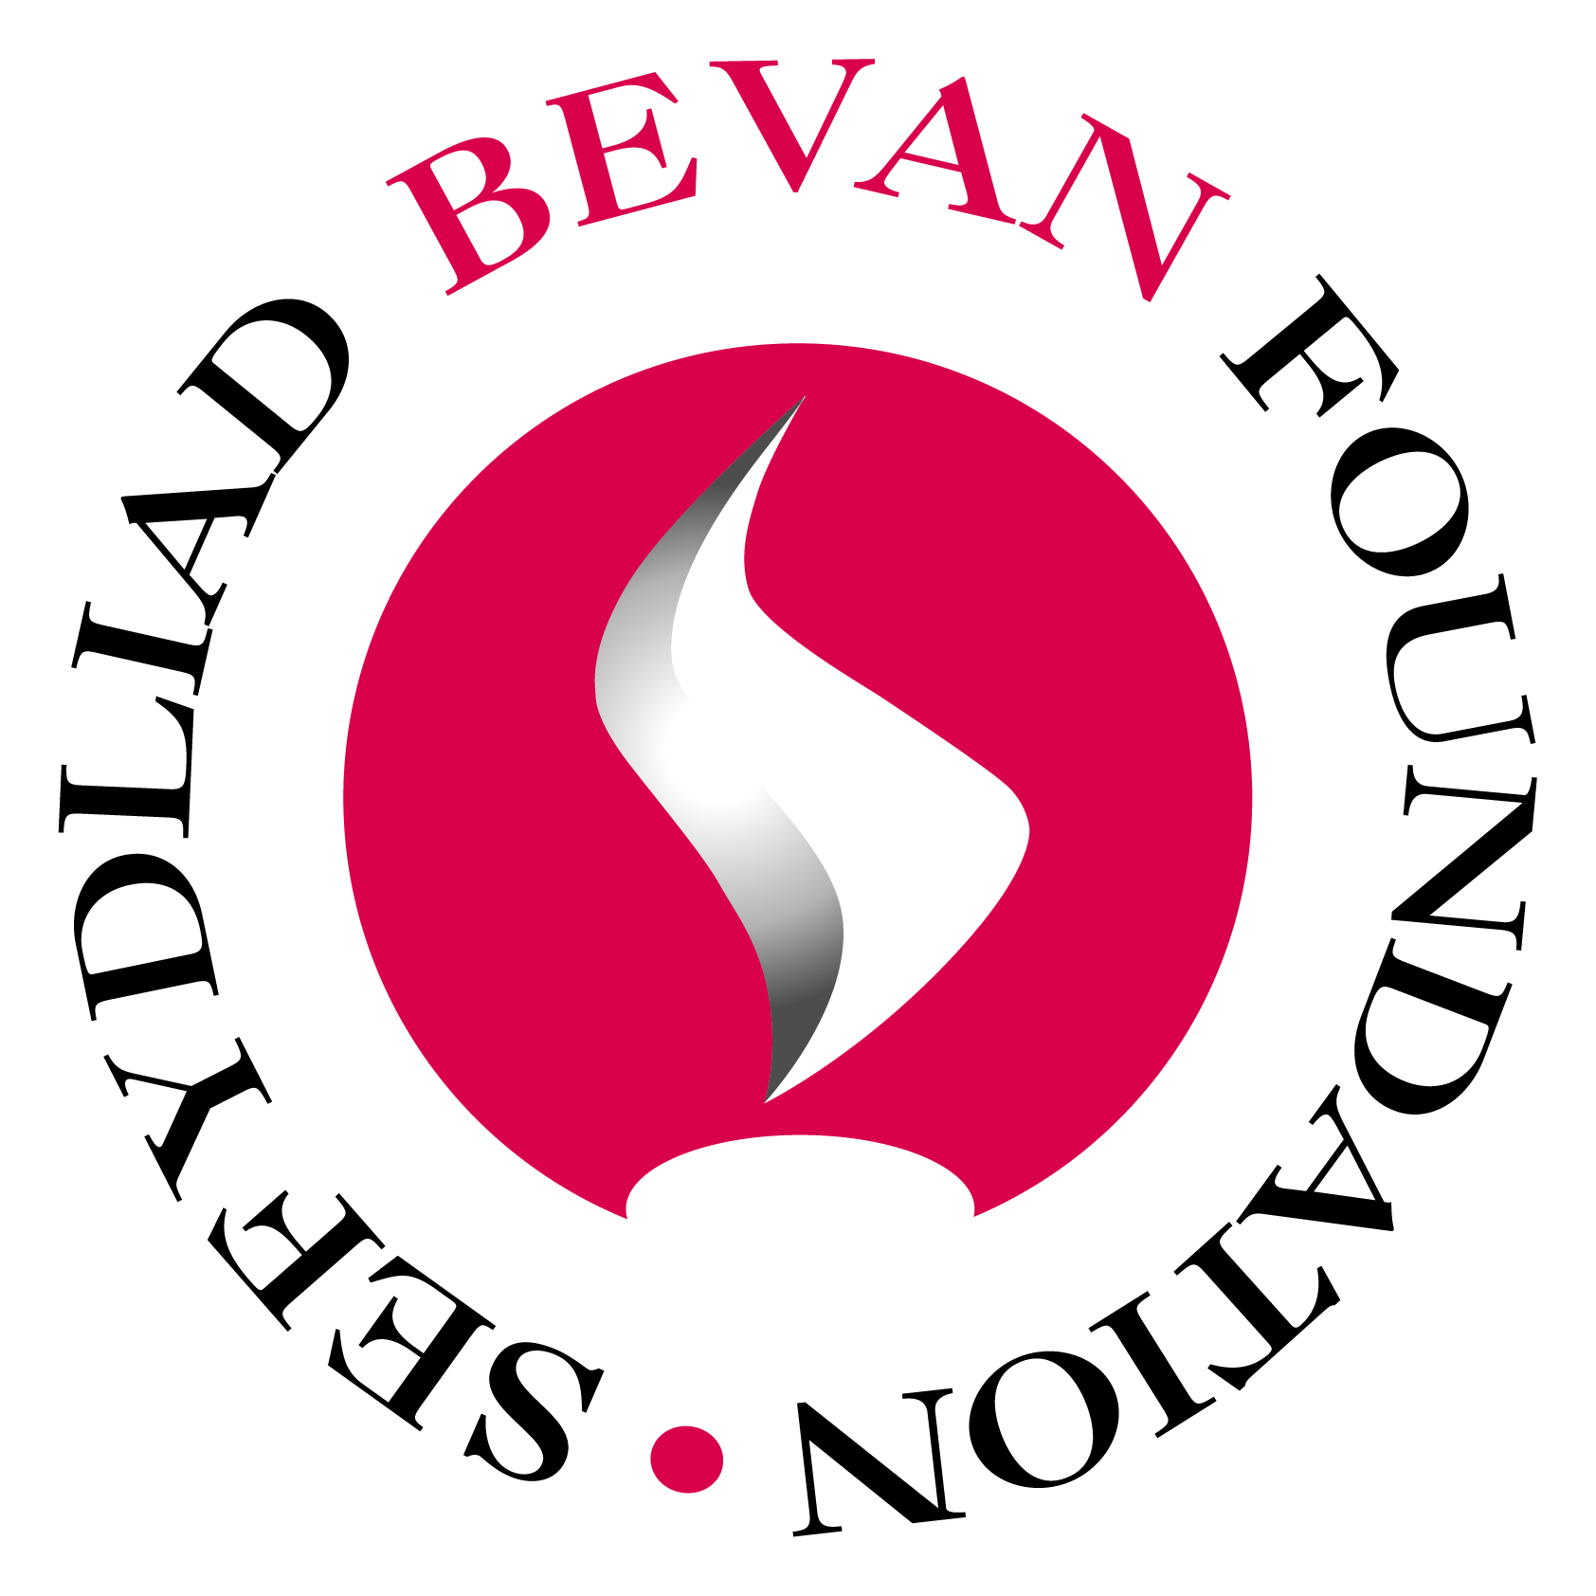
Date issued: Thursday 29th March 2012
Embargoed Until: 00.01 Wednesday 4th April 2012

Bevan Foundation
The Innovation Centre
Festival Drive
Ebbw Vale
NP23 8XA

TEL: 01495 356703
Email: info@bevanfoundation.org
WEB: www.bevanfoundation.org

A New Path Entirely

Now that the Health and Social Care Act in England is on the statute book, Dr. Julian Tudor Hart, a leading thinker on the NHS and originator of the ‘inverse care law’, argues that it is time for the NHS in Wales to take a radically different course.

‘A New Path Entirely’, published today by innovative Welsh think tank the Bevan Foundation, argues that it is time to put the fundamental principles of Bevan’s NHS at its heart. In particular, he says that the Welsh Health Minister should roll-back the four compromises Bevan was forced to make in order to get the NHS on the statute books sixty years ago.

The time is now right, says Dr Tudor Hart, to eliminate consultant private practice and end GP’s role as independent contractors, as both of these arrangements put private profit ahead of patients’ interests. The NHS must become a comprehensive service, he argues, reiterating Bevan’s vision of a service from ‘cradle to grave’ rather than being limited to demand-led clinical medicine. And last, suggests Dr Tudor Hart, it is time to restore local democracy to the NHS. His vision is different – ‘not the shrill voices of demanding consumers’, he says, but ‘the quiet voices of thoughtful people’ who bring their troubles, circumstances and experiences to inform how the NHS should operate.

Dr. Tudor Hart goes on to say that, with these changes, a new Welsh NHS could be attractive to young healthcare professionals wanting to work in health delivered as a public service, with these ‘NHS refugees’ bringing new potential to innovate and inspire further change.

Dr Tudor Hart concludes that “As the U.K. Shadow Cabinet continues to dither in their response to the reforms in England, it will be up to Wales to lead the way in continuing Aneurin Bevan’s dream to end trade in healthcare as a profitable commodity, and develop an NHS aid for by everyone according to their wealth, giving to everyone according to their need”. In 1948 Nye Bevan described this move as a ‘new path entirely’ and this report suggests, we may be back on that path.

ENDS

Contact Details

Daneka Norman, Communications Manager, Bevan Foundation: 01495 3567102 / 07789711659

Victoria Winckler, Director, Bevan Foundation: 01495 356702 / 07771897967

Note to Editors

The Bevan Foundation is an independent ‘think-tank’ that carries out research and encourages debate about social justice in Wales. It is registered charity and social enterprise.

The full report, ‘A New Path Entirely’, will be available to download from www.bevanfooundation.org

Julian Tudor Hart Biography

Julian Tudor Hart was a general practitioner for 35 years, first in London, then in Glyncorrwg, a South Wales coal-mining village. Between these two posts he was apprenticed in epidemiology to Richard Doll and Archie Cochrane. He pioneered community control of hypertension and other chronic conditions, with apparently substantial effects on premature deaths compared with a control population. He returned to full time scientific staff of the Medical Research Council in 1987, retired in 1992, and since then has continued lecturing and writing. The substantially revised second edition of his most recent book The Political Economy of Health Care was published in 2010 by Policy Press. He has published eight other books and over 160 papers in scientific journals, has been visiting professor or lecturer at many UK and foreign universities, is an honorary Fellow of Universities of Swansea, Cardiff, Glamorgan and Glasgow, an honorary DSc at universities of Glasgow and London, and was the first winner of the Royal College of General Practitioners international Discovery Prize for research in primary care in 2006. He joined the Communist Party in 1946, left it in 1978, and has been an active member of the Lab our Party since 1980. If you want any more, look at his illustrated website www.juliantudorhart.org.

